The Columbus Dispatch
Top of Form

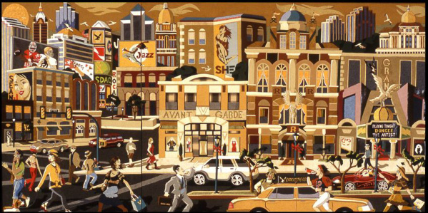COMMENTARY

RTS BLOGS

Don Coulter uses fabric and an X-Acto knife to create scenes of puns and fantasy.
Jazz artists, neighborhoods, city scenes and more serve as subjects for his intricate works.
The exhibit “Don ‘DonCee’ Coulter’s From Fashion to Art” continues through Dec. 28 in the Cultural Arts Center, 139 W. Main St. Gallery hours: 1 to 4 p.m. and 7 to 10 p.m. Mondays, 9 a.m. to
4 p.m. and 7 to 10 p.m. Tuesdays through Thursdays, and 9 a.m. to 4 p.m. Fridays and Saturdays.
Coulter will be the featured speaker for the center’s “Conversations & Coffee” program at noon Thursday.
For more information, call 614-645-7045 or visit www.culturalartscenteronline.org.
— ngilson@dispatch.com

