Behind the Scenes: Painting with fabric



- 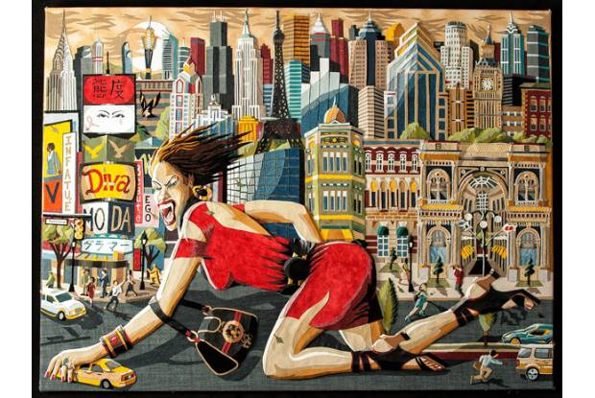
- 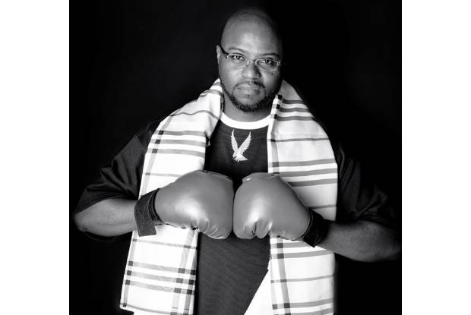

By Jackie Mantey
From the December 13, 2012 edition
Jackie Mantey
“From Fashion to Art”
Cultural Arts Center
Through Dec. 28
139 W. Main St., Downtown
culturalartscenteronline.org
doncee.com
Each time one of her four children “graduated” from sixth grade, my mom made him or her a quilt made from four-by-four-inch squares of denim. I love mine for two main reasons.
One: what a mom thing to do. I’ll forever be her stubborn second-born, who regularly has food in her hair.
Two: Most of the denim came from jeans worn by family members, many while working on their farms. A retired great uncle cut the squares for Mom to then sew. There’s so much familial love sewn into my quilt, it protects me from more than just the cold.
Fabric can tell stories of love and hard work, status and struggle, identity and community.
“I grew up in the era of hip-hop, break-dancing and graffiti,” said artist Don “Doncee” Coulter. “We wanted a unique look that you couldn’t find at the mall so we created it.”
Gutting jean jackets and styling his own clothes eventually led him to study painting. Today, Coulter makes artworks completely out of fabric. They’re so detailed, and the shading and layering are so smart, from far way they look like paintings.
Coulter starts with a sketch of a scene. He breaks down each image into different shapes and planes and transfers them to fabric. His only cutting tool is an X-Acto knife.
The fabric, which can be leather, denim, suede, grill covers or even Gucci bags, is from his closet, thrift stores and generous friends. A company that makes furniture for corporate clients once gave him a trash bag full of leftover leather.
What results are incredibly rich and bright scenes of musicians, landscapes and city life.
“Where I’m From,” for example, is Coulter’s re-imagining of a street he grew up near, drumming with urban life. Even if home looks nothing like this to you (hello, Mantey family dairy farm), the universality of the medium and Coulter’s finesse will remind you of something close to it.
See details of Coulter’s work on Jackie’s Instagram: @JackieMantey.
“Larger Than Life,” by Don “DonCee” Coulter
Coulter photo by James Cline Studios

